**NUMPY CONCAT,STACK:**

**import numpy as np**

**arr1 = np.array([1, 2, 3])**

**arr2 = np.array([4, 5, 6])**

**arr = np.concatenate((arr1, arr2))**

**print(arr)**



**import numpy as np**

**arr1 = np.array([[1, 2], [3, 4]])**

**print("arr1=", arr1)**

**arr2 = np.array([[5, 6], [7, 8]])**

**print("arr2=", arr2)**

**print("after concatenation =")**

**arr = np.concatenate((arr1, arr2), axis=1) #0=row, 1=col**

**print(arr)**

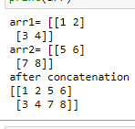

**import numpy as np**

**arr1 = np.array([[1, 2], [3, 4]])**

**print("arr1=", arr1)**

**arr2 = np.array([[5, 6], [7, 8]])**

**print("arr2=", arr2)**

**print("after concatenation =")**

**arr = np.concatenate((arr1, arr2), axis=0) #0=row, 1=col**

**print(arr)**

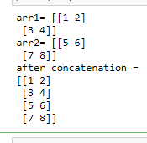

**import numpy as np**

**arr1 = np.array([1, 2, 3])**

**arr2 = np.array([4, 5, 6])**

**arr = np.hstack((arr1, arr2))**

**print(arr)**



**import numpy as np**

**arr1 = np.array([1, 2, 3])**

**arr2 = np.array([4, 5, 6])**

**arr = np.vstack((arr1, arr2))**

**print(arr)**



**a = np.array([1,2,3])**

**b = np.array([4,5,6])**

**print("hstack =", np.hstack((a,b)))**

**print("vstack =", np.vstack((a,b)))**

**a = np.array([[1],[2],[3]])**

**b = np.array([[4],[5],[6]])**

**print("hstack =", np.hstack((a,b)))**

**print("vstack =", np.vstack((a,b)))**

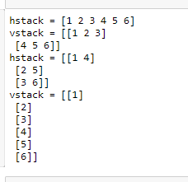

**a = np.array([[1,2,3],[11,22,33],[111,222,333],[1111,2222,3333]])**

**b = np.array([[7,8,9],[77,88,99],[777,888,999],[7777,8888,9999]])**

**print("\nhstack =\n", np.hstack((a,b)))**

**print("\n======next print======")**

**print("\nvstack =\n", np.vstack((a,b)))**

**arr = np.concatenate((a, b), axis=0)**

**print("\n======next print======")**

**print("\n concatenate at axis 0=\n",arr)**

**arr1 = np.concatenate((a, b), axis=1)**

**print("\n======next print======")**

**print("\n concatenate at axis 1=\n",arr1)**

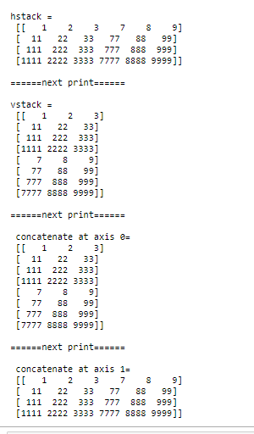

**a= np.array([[1, 2, 3], [4, 5, 6]])**

**print(a)**



**b = np.array([7,8,9])**

**print(b)**



**c = np.array([[7,8,9]])**

**print(c)**



**np.append(a,b, axis=0)**

**OUTPUT: ValueError**: all the input arrays must have same number of dimensions, but the array at index 0 has 2 dimension(s) and the array at index 1 has 1 dimension(s)

**np.append(a,c, axis=0)**

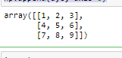

**import numpy as np**

**a = np.array([1,2,3])**

**b = np.array([5,6])**

**np.concatenate((a,b))**



**np.r_[a,b]**



**a = np.array([1, 2,3])**

**b = np.array([5, 6,7])**

**np.stack([a,b]).reshape(-1)**



**a = np.array([1, 2,3])**

**b = np.array([5, 6,7])**

**np.stack([a,b])**

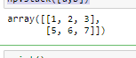

**print()**

**a = np.array([[1,2,3],[11,22,33],[111,222,333],[1111,2222,3333]])**

**b = np.array([[7,8,9],[77,88,99],[777,888,999],[7777,8888,9999]])**

**print("\nhstack =\n", np.hstack((a,b)))**

**print("\n======next print======")**

**print("\nvstack =\n", np.vstack((a,b)))**

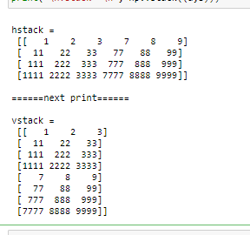

**a = np.array([[1],[2],[3]])**

**b = np.array([[8],[9],[10]])**

**print("\nhstack =\n", np.hstack((a,b)))**

**print("\n======next print======")**

**print("\nvstack =\n", np.vstack((a,b)))**

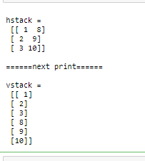

**a = np.array([[1,2],[3,4]])**

**b = np.array([[5,6],[7,8]])**

**print("\nhstack =\n", np.hstack((a,b)))**

**print("\n======next print======")**

**print("\nvstack =\n", np.vstack((a,b)))**

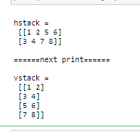

**import numpy as np**

**a = np.array([[1, 2], [3, 4]])**

**b = np.array([[5, 6]])**

**np.concatenate((a, b), axis=0)**

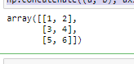

**np.vstack((a,b))**

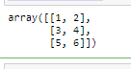

**np.concatenate((a, b), axis=1)**

**OUTPUT: ValueError**: all the input array dimensions for the concatenation axis must match exactly, but along dimension 0, the array at index 0 has size 2 and the array at index 1 has size 1

**np.concatenate((a, b.T), axis=1)**



**import numpy as np**

**a = np.array([[1, 2], [3, 4]])**

**b = np.array([5, 6])**

**bb= np.array([[5, 6],[7,8]])**

**cc=b.T**

**print("vstack=",np.vstack((a,cc)))**

**print("hstack=",np.hstack((a,bb)))**

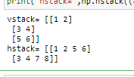

**a = np.array((1,2,3))**

**b = np.array((7,8,9))**

**print(a)**

**print(b)**

**print("vstack\n")**

**print(np.vstack((a,b)))**

**print("concatenate\n")**

**print(np.concatenate([a.reshape(1,3),b.reshape(1,3)]))**

**print("stack\n")**

**print(np.stack((a,b),axis=1))**

**print("concatenate\n")**

**print(np.concatenate((a.reshape(1,3),b.reshape(1,3)),axis = 1))**

**print("stack\n")**

**print(np.stack((a,b),axis=0))**

**print("concatenate\n")**

**print(np.concatenate((a.reshape(1,3),b.reshape(1,3)),axis = 0))**

